## Methodology for Preparation of Canopy Density and Forest Cover Maps at 1: 25000 Scale from Sentinel Data

### Forest Cover Map- Canopy density

Multi-spectral Sentinel Data of 10m resolution will be used for preparation of canopy density maps of Beat at 1:25,000 Scale. Forest canopy density is an essential parameter for characterization of forest conditions. The spatial model used for calculation of Forest Canopy Density from satellite images involves bio-spectral phenomenon modeling and analysis utilizing data derived from following tree indices.

* Advance Vegetation Index (AVI).
* Bare Soil Index (BI).
* Shadow Index or Scaled Shadow Index (SI, SSI).

These tree indices together in the canopy density are calculated in percentage for each pixel. Satellite data of October-November (2018) will be used for canopy density estimation as it is the time period of maximum vegetation growth.

Advance Vegetation Index (AVI) is calculated through the equation AVI = {(B4 +1) (256-B3) (B4-B3)]1/3, where B4 is NIR and B3 is Red Band.

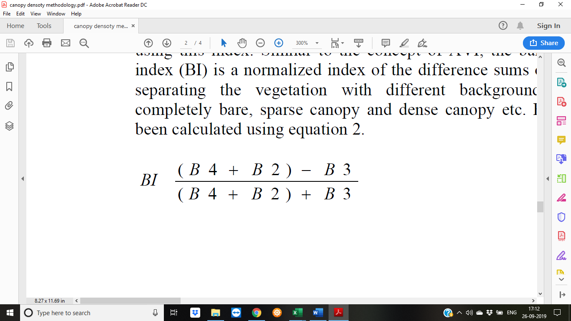Bare Soil Index (BI) is calculated as

Where B2 is Green Band

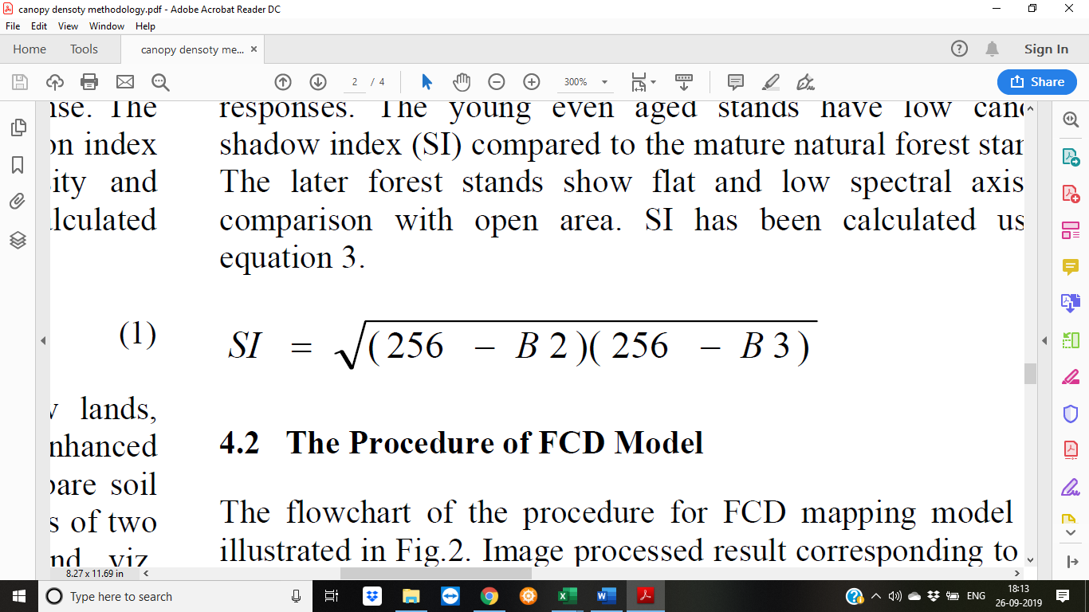

Shadow Index is calculated as

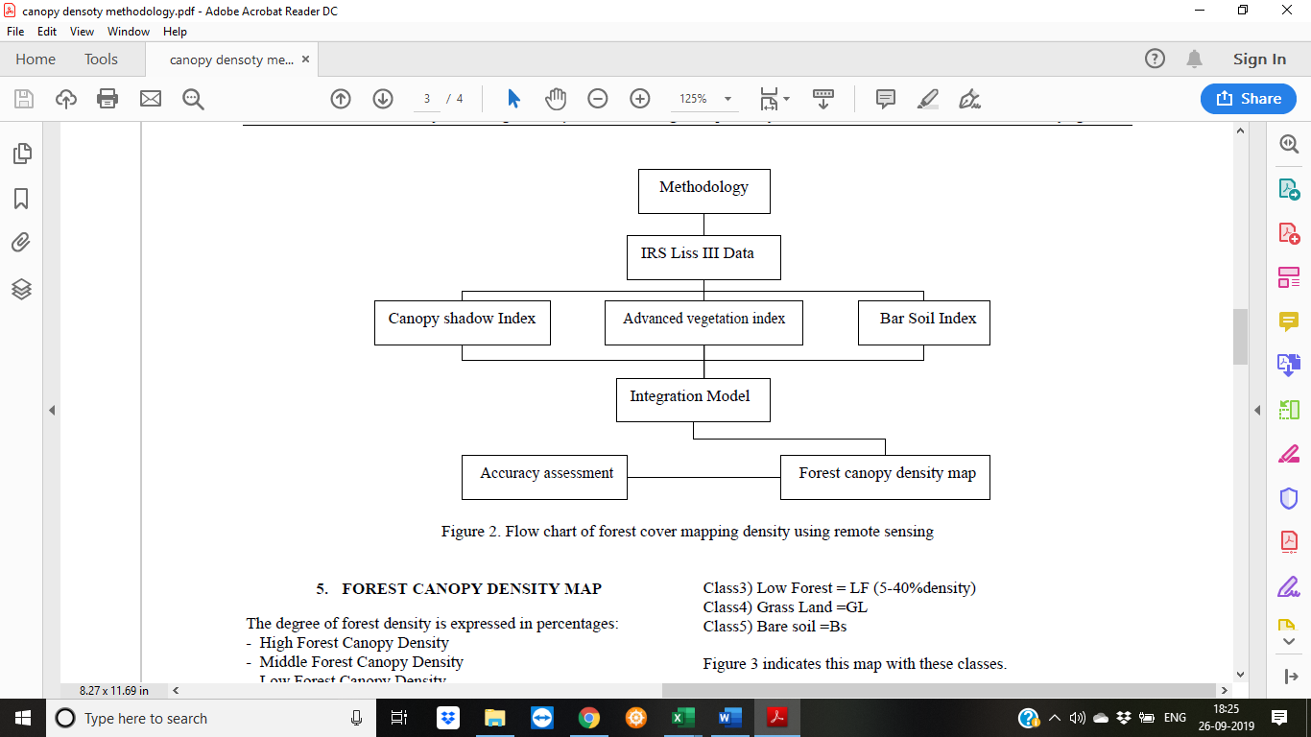

Sentinel Data

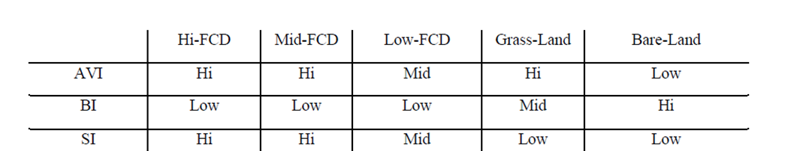

Highly Dense Forest =HF (81-100% density)

Dense Forest = DF (61-80% density)

Moderately Dense Forest =MF (41-60% density)

Low Density Forest = LF (21-40% density)

Very Low Density Forest = OF (5-20% density)

Grass Land = GL

Bare Soil = BS

After the classification, based on the understanding of the region. The maps are then taken for ground truthing and corrected with the information from the field.

### Forest Cover Map- Vegetation Type and Stock Type Map

Multi-spectral Sentinel Data of 10m resolution will be used for preparation of vegetation type maps and stock maps of Beat at 1:25,000 Scale. Vegetation Type and Stock Type are essential parameters for characterization of forest conditions. The calculation of Type maps from satellite images involves analysis utilizing data derived from Normalized Difference Vegetation Index (NDVI) calculated as IR-R/IR+R.

Monthly Sentinel data will be downloaded and processed to prepare FCC of the area. NDVI of every month will be calculated. NDVI for all the 12 months will be calculated similarly from Sep 2018 to Sep 2019. (exclude the months/scenes with cloud data).

NDVI for each month is then stacked through layer stack and run Unsupervised Classification. Classification is then done based on Champion and Seth Classification for Vegetation Type and Stock Maps based on growing stock in the field.

After the classification, based on the understanding of the region. The maps are then taken for ground truthing and corrected with the information from the field.

Satellite Data - Monthly

NDVI

Unsupervised Classification

Vegetation Type Map

Ground Truthing

Champion and Seth Classification

Satellite Data - Monthly

NDVI

Unsupervised Classification

Stock Type Map

Ground Truthing

Growing Stock Classification